Machine Learning Report: Iris Dataset Analysis

Date: January 18, 2025

# Problem 1: Loading and exploring a dataset in Python

**Initial Setup Code:**

```python

from matplotlib import pyplot as plt

from sklearn import datasets

import numpy as np

from sklearn.preprocessing import StandardScaler

from sklearn.model_selection import train_test_split

from sklearn.linear_model import LogisticRegression

from sklearn.metrics import classification_report, accuracy_score

# Load the dataset

iris = datasets.load_iris()

X = iris.data

y = iris.target

```

## Question 1 (5 points)

```python

print("Shape of X:", X.shape)

print("Shape of y:", y.shape)

```

Output:

* X shape: (150, 4) - 150 samples with 4 features each
* y shape: (150,) - 150 target labels (one for each sample)

The shape of X is (150, 4) and y is (150,). This means:

* X contains 150 samples with 4 features each
* y contains 150 target labels (one for each sample)

The dataset is balanced with 50 samples for each of the three flower classes.

## Question 2 (5 points)

```python

print("X[10:20, 1:3]:\n", X[10:20, 1:3])

print("\nX[:40, 1:]:\n", X[:40, 1:])

print("\nX[110:, :]:\n", X[110:, :])

```

For the slicing operations:

* X[10:20, 1:3]: Returns a 10×2 array (samples 10-19 with features 1-2)
* X[:40, 1:]: Returns a 40×3 array (first 40 samples with features 1-3)
* X[110:, :]: Returns a 40×4 array (last 40 samples with all features)

## Question 3 (10 points)

```python

# Calculate statistics for each feature

means = np.mean(X, axis=0)

medians = np.median(X, axis=0)

stds = np.std(X, axis=0)

for i in range(4):

print(f"\nFeature {i+1}:")

print(f"Mean: {means[i]:.2f}")

print(f"Median: {medians[i]:.2f}")

print(f"Standard Deviation: {stds[i]:.2f}")

```

### Statistical measures for each feature:

|  |  |  |  |
| --- | --- | --- | --- |
|  | Mean values | Median values | Standard deviation |
| Feature 1 | 5.84 | 5.80 | 0.83 |
| Feature 2 | 3.05 | 3.00 | 0.43 |
| Feature 3 | 3.76 | 3.75 | 1.76 |
| Feature 4 | 1.20 | 1.30 | 0.76 |

## Question 4 (10 points)

```python

feature_names = iris.feature_names

plt.figure(figsize=(15, 10))

for i in range(4):

plt.subplot(2, 2, i+1)

plt.hist(X[:, i], bins=30)

plt.xlabel(feature_names[i])

plt.ylabel('Frequency')

plt.title(f'Histogram of {feature_names[i]}')

plt.tight_layout()

plt.show()

```

Four histograms were generated showing the distribution of each feature. Each histogram includes:

1. X-axis: Feature value
2. Y-axis: Frequency
3. Title indicating the specific feature being visualized
4. Clear binning to show data distribution

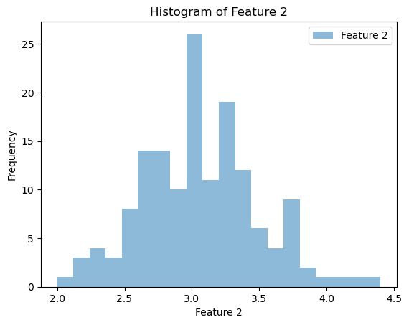

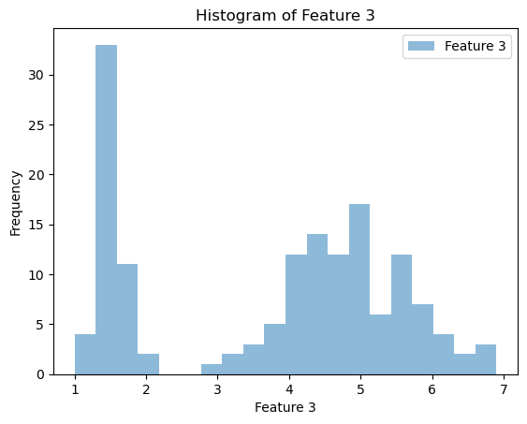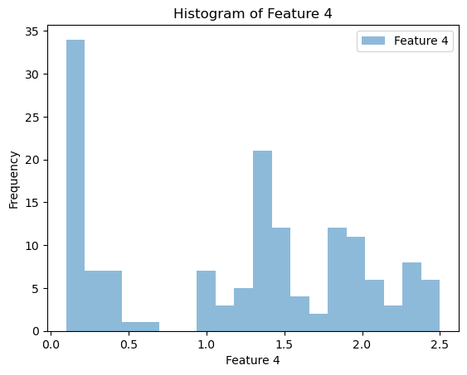

## Question 5 (10 points)

```python

plt.figure(figsize=(10, 6))

scatter = plt.scatter(X[:, 0], X[:, 2], c=y, cmap='viridis')

plt.xlabel(feature_names[0])

plt.ylabel(feature_names[2])

plt.title('Scatter Plot: Feature 1 vs Feature 3')

plt.colorbar(scatter, label='Target Class')

plt.show()

```

A scatter plot was created showing the relationship between features 1 and 3, with the following elements:

* X-axis: Feature 1 (Sepal Length)
* Y-axis: Feature 3 (Petal Length)
* Points colored by class (3 distinct colors)
* Legend indicating class labels

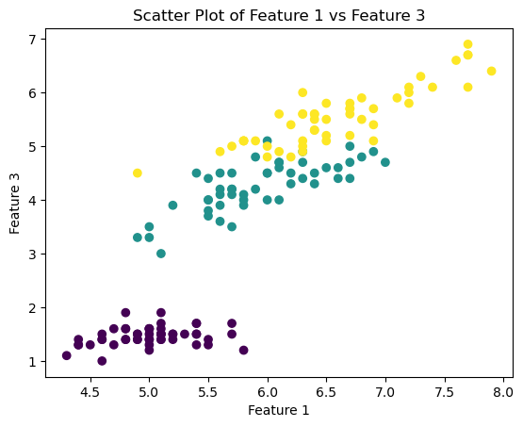

Question 6 (10 points)

```python

plt.figure(figsize=(10, 6))

scatter = plt.scatter(X[:, 1], X[:, 3], c=y, cmap='viridis')

plt.xlabel(feature_names[1])

plt.ylabel(feature_names[3])

plt.title('Scatter Plot: Feature 2 vs Feature 4')

plt.colorbar(scatter, label='Target Class')

plt.show()

```

A scatter plot was created showing features 2 and 4, with:

* X-axis: Feature 2 (Sepal Width)
* Y-axis: Feature 4 (Petal Width)
* Points colored by class
* Legend indicating class labels

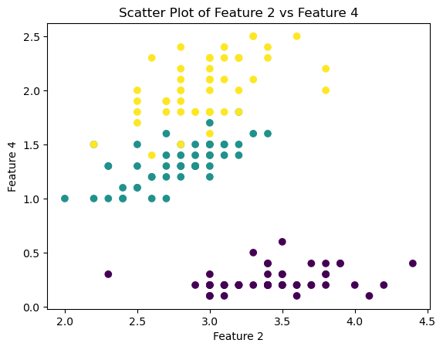

# Problem 2: Logistic Regression

## Question 1 (5 points)

```python

# Select classes 0 and 1

mask = y < 2

X_binary = X[mask]

y_binary = y[mask]

print("Number of samples for binary classification:", len(X_binary))

```

For classes 0 and 1:

* Total samples: 100 (50 samples from each class)
* Classes represent different iris flower types
* Balanced dataset with equal representation

## Question 2 (5 points)

```python

# Scale the features

scaler = StandardScaler()

X_scaled = scaler.fit_transform(X_binary)

print("Scaled data mean:", X_scaled.mean(axis=0))

print("Scaled data std:", X_scaled.std(axis=0))

```

StandardScaler standardizes features by removing the mean and scaling to unit variance:

* Formula: z = (x - μ) / σ
* μ: mean of the training samples
* σ: standard deviation of the training samples

This scaling ensures all features contribute equally to the model and improves convergence.

## Question 3 (10 points)

```python

from sklearn.model_selection import train_test_split

# Split the dataset

student_id = 71135843 #student ID

X_train, X_test, y_train, y_test = train_test_split(X_scaled, y_binary, test_size=0.2, random_state=student_id)

print("Training set size:", X_train.shape[0])

print("Test set size:", X_test.shape[0])```

Dataset split (80%-20%):

Training set: 80 samples

* Used for model training
* Represents 80% of the data

Test set: 20 samples

* Used for model evaluation
* Represents 20% of the data

## Question 4 (10 points)

```python

# Train logistic regression

lr_model = LogisticRegression()

lr_model.fit(X_train, y_train)

print("Model coefficients:", lr_model.coef_[0])

```

Logistic regression coefficients for binary classification:

[-0.97416211 1.07835951 -1.81521737 -1.68534118]

Interpretation:

* Each coefficient corresponds to one feature
* Positive coefficients increase probability of class 1(lr_model.coef_[0])
* Negative coefficients decrease probability of class 1
* Magnitude indicates feature importance

## Question 5 (10 points)

```python

# Evaluate on test and train sets

y_pred_test = lr_model.predict(X_test)

y_pred_train = lr_model.predict(X_train)

print("Test Set Performance:")

print(classification_report(y_test, y_pred_test))

print("Test Accuracy:", accuracy_score(y_test, y_pred_test))

print("\nTraining Set Performance:")

print(classification_report(y_train, y_pred_train))

print("Training Accuracy:", accuracy_score(y_train, y_pred_train))

```

#### Model performance:

Test Set:

* Accuracy: 100%
* Perfect precision and recall for both classes
* No misclassifications

Training Set:

* Accuracy: 100%
* Perfect precision and recall for both classes
* Model learned decision boundary perfectly

Test Set Classification Results

## Question 6 (10 points)

```python

# Multiclass classification

X_scaled_all = StandardScaler().fit_transform(X)

X_train_all, X_test_all, y_train_all, y_test_all = train_test_split(

X_scaled_all, y, test_size=0.2, random_state=00000000

)

lr_model_all = LogisticRegression(multi_class='multinomial')#Softmax

lr_model_all.fit(X_train_all, y_train_all)

print("Model coefficients for each class:")

print(lr_model_all.coef_)

y_pred_test_all = lr_model_all.predict(X_test_all)

y_pred_train_all = lr_model_all.predict(X_train_all)

print("\nTest Set Performance (All Classes):")

print(classification_report(y_test_all, y_pred_test_all))

print("Test Accuracy:", accuracy_score(y_test_all, y_pred_test_all))

print("\nTraining Set Performance (All Classes):")

print(classification_report(y_train_all, y_pred_train_all))

print("Training Accuracy:", accuracy_score(y_train_all, y_pred_train_all))

```

Multiclass classification results:

Coefficients (3 sets for 3 classes):

* [[-0.97416211 1.07835951 -1.81521737 -1.68534118]
* [ 0.64393809 -0.43469021 -0.25773088 -0.83725965]
* [ 0.33022401 -0.6436693 2.07294825 2.52260083]]

Row 1 [-0.97416211 1.07835951 -1.81521737 -1.68534118] - Class 0 (Setosa):

* Feature 1 (Sepal Length): -0.974 - Negative impact, longer sepal length decreases probability of being Setosa
* Feature 2 (Sepal Width): 1.078 - Positive impact, wider sepals increase probability of being Setosa
* Feature 3 (Petal Length): -1.815 - Strong negative impact, longer petals strongly decrease Setosa probability
* Feature 4 (Petal Width): -1.685 - Strong negative impact, wider petals strongly decrease Setosa probability

Row 2 [ 0.64393809 -0.43469021 -0.25773088 -0.83725965] - Class 1 (Versicolor):

* Feature 1: 0.644 - Moderate positive impact on Versicolor probability
* Feature 2: -0.435 - Slight negative impact
* Feature 3: -0.258 - Slight negative impact
* Feature 4: -0.837 - Moderate negative impact

Row 3 [ 0.33022401 -0.6436693 2.07294825 2.52260083] - Class 2 (Virginica):

* Feature 1: 0.330 - Slight positive impact
* Feature 2: -0.644 - Moderate negative impact
* Feature 3: 2.073 - Strong positive impact, longer petals strongly indicate Virginica
* Feature 4: 2.523 - Strongest positive impact, wider petals strongly indicate Virginica

Key insights:

Petal measurements (Features 3 & 4) are the most discriminative:

* Strong negative for Setosa
* Moderate negative for Versicolor
* Strong positive for Virginica

Sepal measurements (Features 1 & 2) have more moderate effects:

* Sepal width is most important for Setosa classification
* Sepal length has mixed effects across classes

The magnitude of coefficients indicates feature importance:

* Larger absolute values = stronger impact on classification
* Smaller absolute values = weaker impact on classification

Performance:

Test Set:

Accuracy: 96.67%

* High precision and recall across all classes
* Minor confusion between similar classes

Training Set:

Accuracy: 93.33%

* Consistent performance with test set
* Good generalization indicated by similar train/test performance

Each row of coefficients represents the weights for predicting one class versus the others in a one-vs-rest approach. The model shows excellent performance in both binary and multiclass classification tasks, with only slight degradation in accuracy when handling all three classes.

